

School of Systems and Technology

**Web Technologies**

Section: Y2

Submitted By:

Name: Haiqa Humayun

ID: F2020105110

Submission Details:

Assessment Detail: Assignment 01

Submission Date: 17 March 2023

Submitted to:

Instructor: Sir Ali Harris

Marks Obtained: _____________________________

HTML WEBPAGE

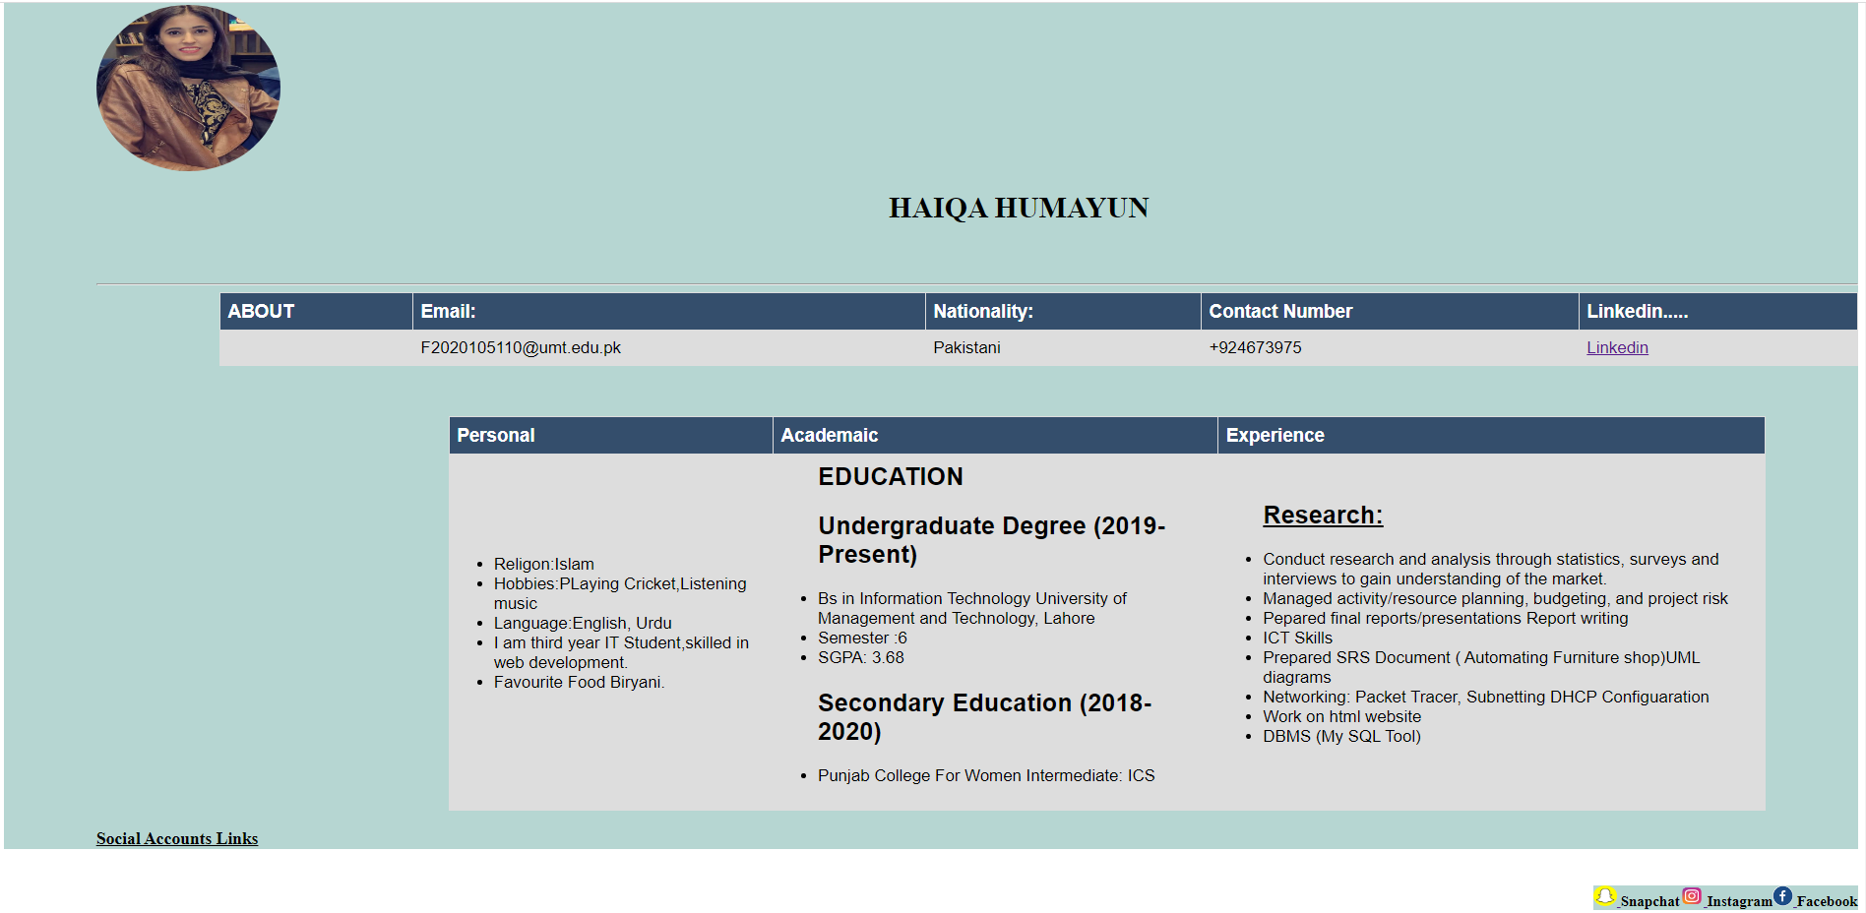

Code:

<!DOCTYPE html>

<html>

<title>"Resume"</title>

<head>

<style>

table, th, td {

border: 1px solid black;

border-collapse: collapse;

font-size: 18px;

font-family: arial;

}

table {

width: 90%;

}

th {

background-color:rgb(52, 78, 108);

color: white;

font-size: 20px;

}

.a{

background-color:rgb(182, 214, 210);

}

.c{

margin-left: 20%;

}

.d{

margin-left: 45%;

margin-bottom:5%;

}

.f{

margin-left: 7%;

}

.e{

padding-top: 20px;

margin-left: 5%;

}

img {

border-radius: 50%;

}

</style>

</head>

<body>

<div class=" a">

<div class=" e" style="direction:row">

<img src="Haiqa.jpg" alt="My Profile Picture" width="200" height="180" style="align-right"float:"left"/>

<div class="d" styles="display:flex">

<h1 style="float:left;margin-right:50px; " >HAIQA HUMAYUN</h1>

</div> <br>

<hr>

<div class="f">

<style>

table {

font-family: arial, sans-serif;

border-collapse: collapse;

width: 100%;

}

td, th {

border: 1px solid #dddddd;

text-align: left;

padding: 8px;

}

tr:nth-child(even) {

background-color: #dddddd;

}

</style>

</head>

<body>

<table>

<tr>

<th>ABOUT</th>

<th>Email:</th>

<th>Nationality: </th>

<th> Contact Number</th>

<th>Linkedin.....</th>

</tr>

<tr>

<td>

<td> F2020105110@umt.edu.pk</td>

<td> Pakistani</td>

<td> +924673975</td>

<td> <a href="https://www.linkedin.com/in/haiqa-humayun-36037824a" target="blank">Linkedin</td>

</td>

</tr>

</table>

<br><br><br>

</div>

<div class=" c" style="margin-right:100px">

<table >

<tr>

<th >Personal</th>

<th > Academaic</th>

<th >Experience</th>

</tr>

<tr>

<td><dl>

<ul>

<li> Religon:Islam</li>

<li>Hobbies:PLaying Cricket,Listening music</li>

<li>Language:English, Urdu</li>

<li>I am third year IT Student,skilled in web development.</li>

<li>Favourite Food Biryani.</li>

</ul></td>

<td><ul>

<h2>EDUCATION</h2>

<h2>Undergraduate Degree (2019-Present)</h2>

<li>Bs in Information Technology University of Management and Technology, Lahore</li>

<li>Semester :6</li>

<li>SGPA: 3.68</li>

<h2>Secondary Education (2018-2020)</h2>

<li>Punjab College For Women Intermediate: ICS</li>

</li>

</ul></td>

<td><ul >

<u><h2>Research:</h2></u>

<li>Conduct research and analysis through statistics, surveys and interviews to gain understanding of the market.</li>

<li>Managed activity/resource planning, budgeting, and project risk</li>

<li>Pepared final reports/presentations Report writing</li>

<li>ICT Skills</li>

<li>Prepared SRS Document ( Automating Furniture shop)UML diagrams </li>

<li>Networking: Packet Tracer, Subnetting DHCP Configuaration</li>

<li>Work on html website</li>

<li>DBMS (My SQL Tool)</li>

</ul></td>

</tr>

</table>

</div>

<u><h3>Social Accounts Links</h3></u>

<div class="z" style=" direction:row;background-color:rgb(182, 214, 210)">

<div class="f" background-color:rgb(182, 214, 210)>

<h4 style="float:right;background-color:rgb(182, 214, 210)"><a href="https://www.facebook.com/haiqa.humayun?mibextid=ZbWKwL"target="blank"><img src="https://www.seekpng.com/png/small/26-267842_facebook-round-logo-png-transparent-background-facebook-logo.png" alt="Facebook Link" style="width:22px;height:22px;"> </a>Facebook</h4>

<h4 style="float:right;background-color:rgb(182, 214, 210)"><a href="https://instagram.com/_haiqa_humayun?igshid=NmQ2ZmYxZjA="target=" blank"><img src="https://png.pngtree.com/png-clipart/20180626/ourmid/pngtree-instagram-icon-instagram-logo-png-image_3584852.png" alt="Instagram Link" style="width:26px;height:22px;">

</a>

Instagram</h4>

<h4 style="float:right;background-color:rgb(182, 214, 210)"><a href="https://www.snapchat.com/add/haiqa_humayun?share_id=5xo9sJ_vVfw&locale=en-US"target="blank"><img src="https://assets.stickpng.com/images/580b57fcd9996e24bc43c536.png"alt="Instagram Link" style="width:26px;height:22px;">

</a> Snapchat</h4>

</div>

</div>

</div>

</body>

</html>